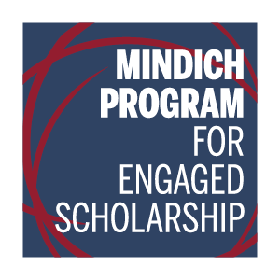  FALL 2017 COURSES  MAKE AN IMPACT  - Integrate community engagement with your coursework  - Take learning outside the classroom  - Connect with organizations and community members beyond Harvard  FOR MORE INFORMATION, CONTACT:  Flavia C. Peréa, Director  Mindich Program for Engaged Scholarship  Phillips Brooks House, Room 305  flaviaperea@fas.harvard.edu  engagedscholarship.fas.harvard.edu | SOC-STD 68EC  Education and Community  in America:  Universities and Community Engagement, 1890-2017  Ariane Mary Liazos  Mon: 12-3PM  SOC-STD 68UH  Urban Health and Community Change:  Action Planning With Local Stakeholders  Flavia Peréa  Wed: 1-4PM  SPANSH 59  Spanish and the Community  María Parra-Velasco  Tues & Thurs: 10-11:30AM  SLAVIC 189  The Other Russia:  Twenty-First Century Films, Fictions, States of Mind  (Engaged Scholarship  Course Module)  Stephanie Sandler  Tues & Thurs: 2-3:30PM

